1
Kusna ke saht empire sahbh use kyaia gya hai kusan ko samrajay bola jat hai because Mauryan ke decline ke baad ek bahtu bade Chetra per kise ne adhikar kyia to wo kushano ne kyia tha kushnao ki north border china se jakar laagta tha and south border vidnaya mountain and kachh ke khadi se jakr lagte the wahe purvi seema bhiar se jakar lagte the aur paschimi seema afganistan and central asia wale Chetra se jakar lagte the to yahe karna hai Kushan k lyie empire word use kyia jata hai kuki inhone bahtu bade Chetra per shahsan kyia tha

Kusahn ka bhartyia history me important isthan hai
Jaise kusahn ka ek rajaj hai kanishk first jisne Mahayana buddhism ka bahut Jayda vikas kyia tha usme mahayan buddhism ko bahut promote kyia
Buddha dharma ke agar do sabse bade ashryadata rahe hai to wo ke Ashoka and second is kansihka first

Kushano ne bharat me sabse shudh pure gold coin chaleey the
Gold coin sabse pahle indo Greek ruler ne chaley the use pahle iraneya ne bhe chaley bhaut unko itan imaprct nahi tha
Isley who isseue gold coin fist in india
AmnS: indo Greek ruler inhone sabshe bpahels sytstematic roop se gold coin chalaye the

Bharat me sabse pure gold coins?
Ans:Kushan

Bharat me sabse Jayda gold coin kisne chalaye
To answer is Gupta

Kushano ka ek aur aur significat yogdan bharat me ye rahah ke
Inke samay murti art ke ek new shaile vikset hue jise hum Gandhar art ke naam se jante hai
Mathura kaala shaile bhartat ke apne swadeshi murit Nirman ke shaile hai

Wahe jo Gandhar art ke sahile hai usme bhartyia and Greek kala ka mix karke mbanaya gaya hai
Usme Indian and Greek art ko mix kkya gayay hai Gandhar shaile me

Kusano ka jo sabse bada rjaj tha kanishk usne Resham marg silk route ko control kyia tha

In sabe krno se kushano ka bhartyia iethass me mahtvapurna yogdaan hai
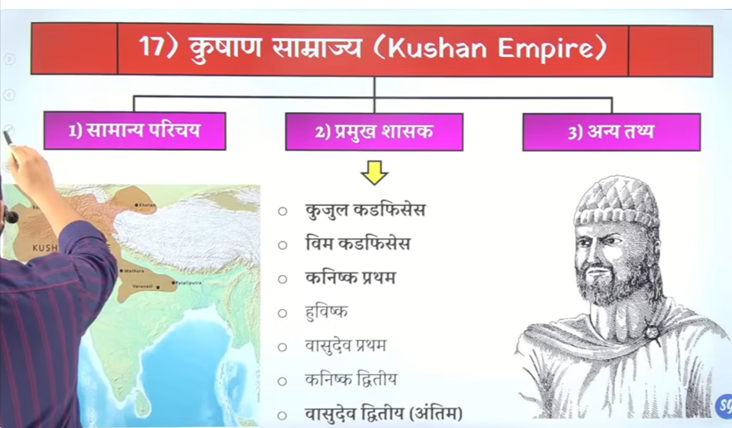

Gandhar and mauthua kaala me difference
Bamiyaan budha ke prateema jo ke afganistan me bahagwan buddha ke ek khadi hue prateema the unfrotuanatly Taliban ne usko destroy kar dyia
Bamyian buddhsim ke bare me bhe janege

Inke capital the purushpur jisse aja hum Peshawar ke naam se jante hai and Mathura inke second capital the
Shatak naam ka ek vastra hai jiska Nirman hota tha Mathura me jo ke bahut bada vayparke kendar ban gyaa tha Mathura me

Inka orgin
Ye central asia aur china ke chetro se hua hai paschimi china and central asia wale Chetra se kusano ki utaptee origin mana jat ahi
Yaha Yuchi naam ke ek tribe janjate hue the jiseke 5 aalg alag branches hai
In branch me ske ek branch cha kanga naam ke branch wo bharat ate hai isme se ke perison jiska naam tha kuzul kadfisyes usne Kushan samrajya ke isthapaan ke

To kusano ke jo root hai wo centra aisa aur west china me rahen wale Yuchi janjati tribme me milte hai wahah per 5 branch the jisme se ke branch bharat ate hai usmee ke person kuzuzl kadfisses ne Kushan samray ke isthapan ke the inhone purushpur ko apne catial banya
Mathura ko second rajdahni
Kanishak inka sabse maahn sahask hua
Inme jo adhinkansh rjaaj the wo devputra ke tietel dharan karte the

Note sabse sudh gold coin kushnao ne jaree kyia tha t
Maxiumu numbr of gold coin were issued by gupta rulers

And first gold coin issued by indo Greek ruler in idnia or indo bacterian ruler

Kuzul kadfeses ne cooper coin issue kyia tha isne gold coin issue nahi kaya tha and kushano ke line me sabse pahle vim kadfissye ne gold coin chalye in only Kushan line
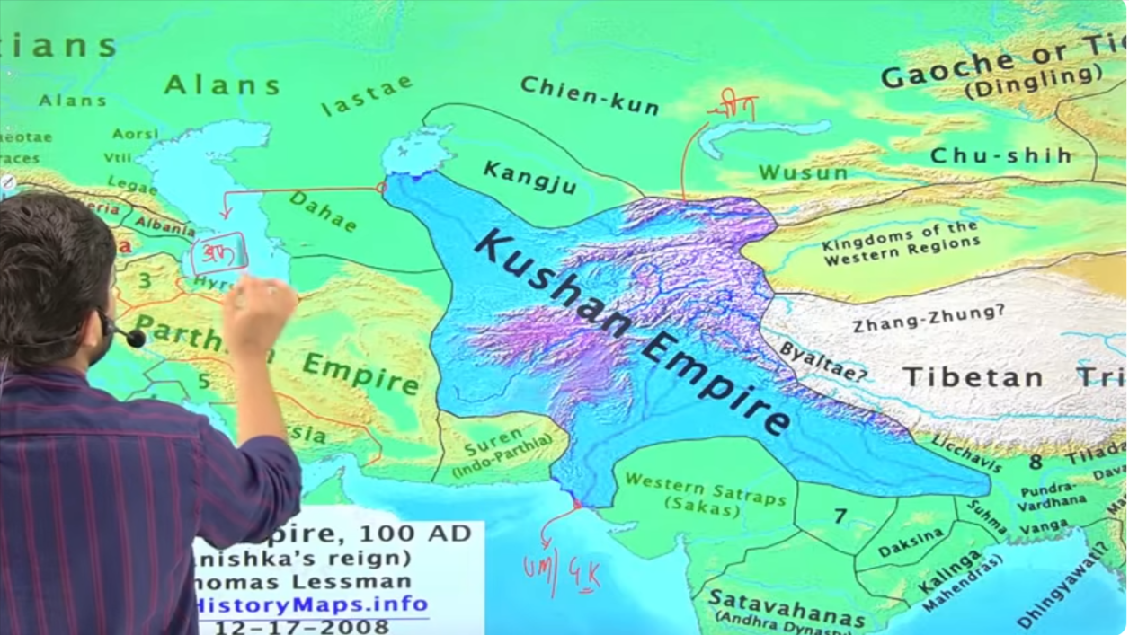

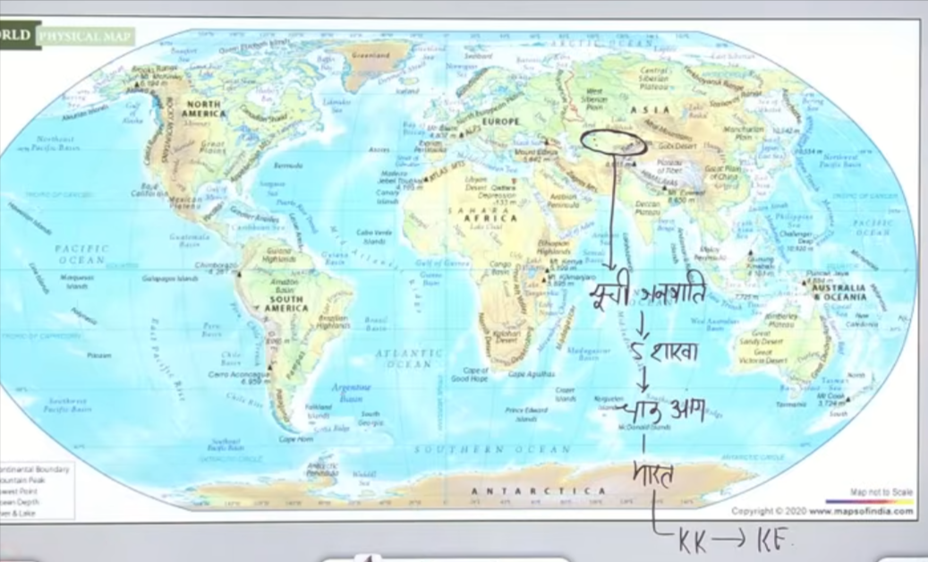

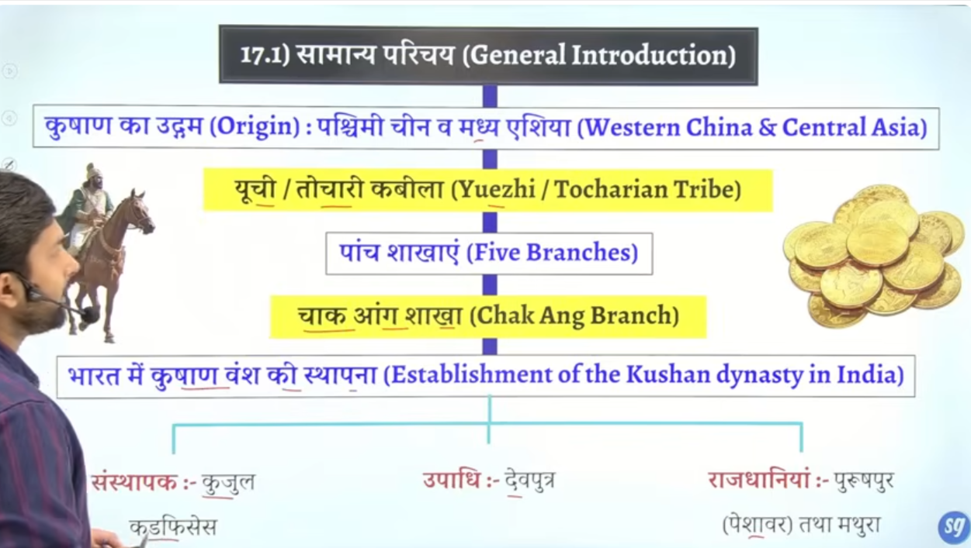
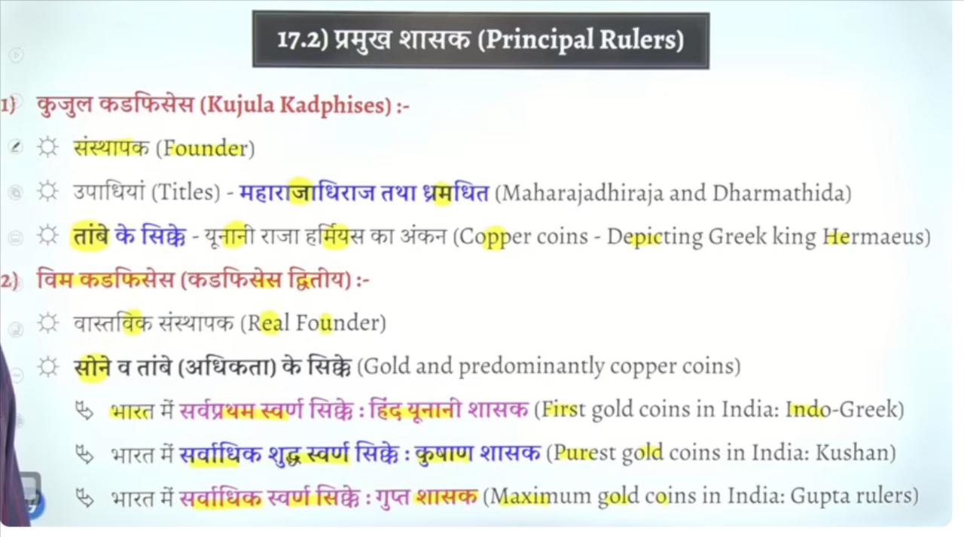

Vim kadfieses shaiv mat ka anuyayee tha kuki uske sikko per Bhagwan shiva trisholl nandi ka ankan milta hai

Age chalkar hume kansihka ke sikko per buddha ke manav roop ka ankan milta hai aur Kanishka ke siko per aur kanishak ke ssiko per he hume sabse pahle maitryea ka ankan milta hai jo ki future buddha hai
To coin se pata chalta hai ke vim kadfesaey shiavv mat ka anuyaee tha aur kanshika first mahanya buddhsim ka anyuase tha
To coins bahut kuch jankare dete hai

Post mouran time ke jo vedhsie forieng rulers hai hume unke jankari coins se milte ahi to iss tarah se coins me alag alag image ka ankan kyia gaya hai hume isse pahle buddha jo coins me ankana nahi milta hai sabse pahle buddho ko coins per depict karne ka kaam kanshika ne kyat ha maitrey ka ankan bhe kanshika ne karway tha
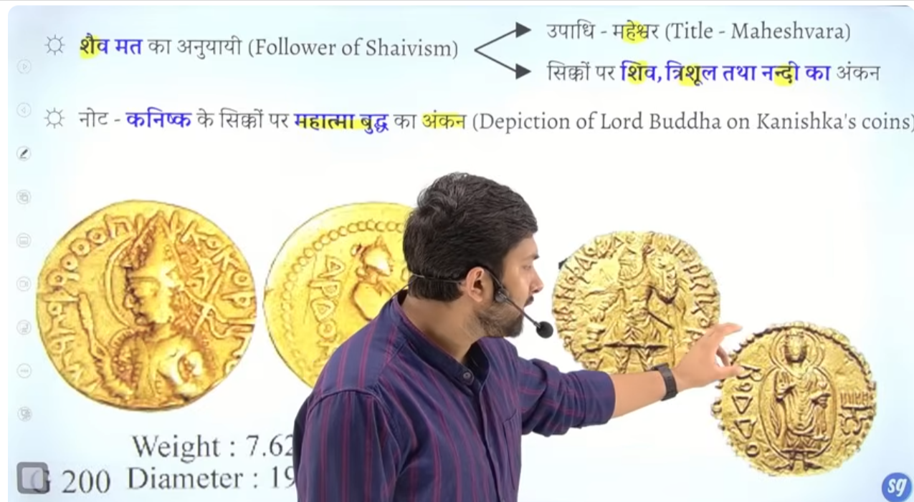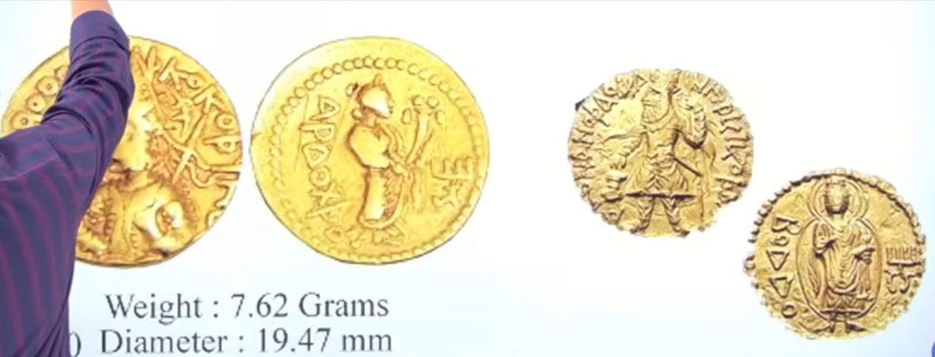

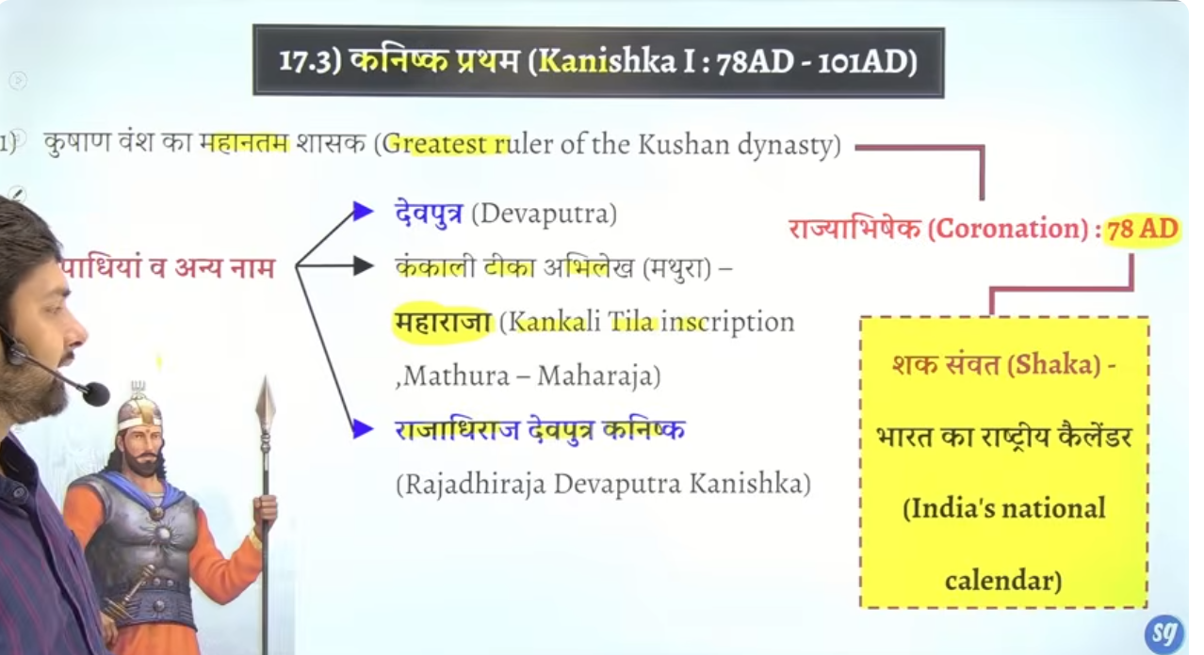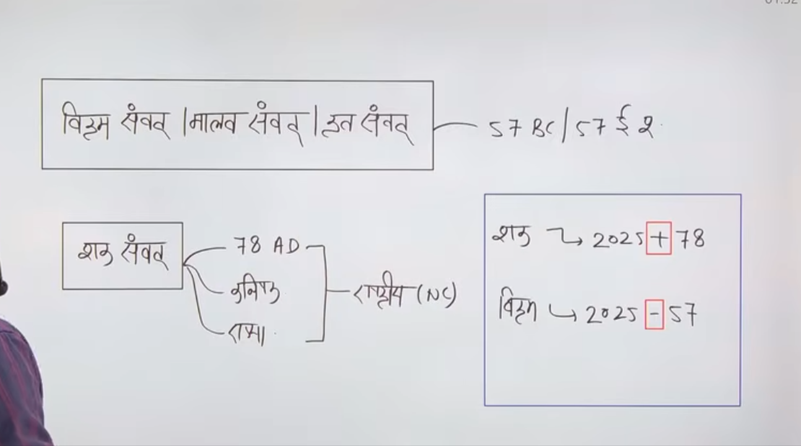

Most prominent ruler is kansihka first
Jb iksa rajyabadheshki coronation hua to issne shak Samvat ko jari kyia tha jo ke bharat ka national calender hai
Isse pahle hume jo calendar pada tha uska name tha Vikram Samvat ya malva Samvat, krat Samvat
Iske Shurat 57BCE me hue the
Dusra Samvat hai ye hai
Shak Samvat ike Shurat hue hai 78Ce me ikse Shurat kanhiska ne ki hai is time per kanhika ka cornoaiton hau tha and shako ke victory ke uplaksahya me usne ye Samvat jare kyia tha

This is the natinal calendar of india at resent time
Kanishka ne sak Samvat ke shruat ke the
Baki hum Gregorian calendar ko follow krte hai ukse alag story hai

Kansihak ne bahtu sare title lyia jisme se ke hai devputra jo lagabha kusan ne sare rajao ne le krakah tha
Mathura ke kankali teeka inscritpon me usko maharaja title mention hai
Whah per usne apne apko ko maharja kaha hai

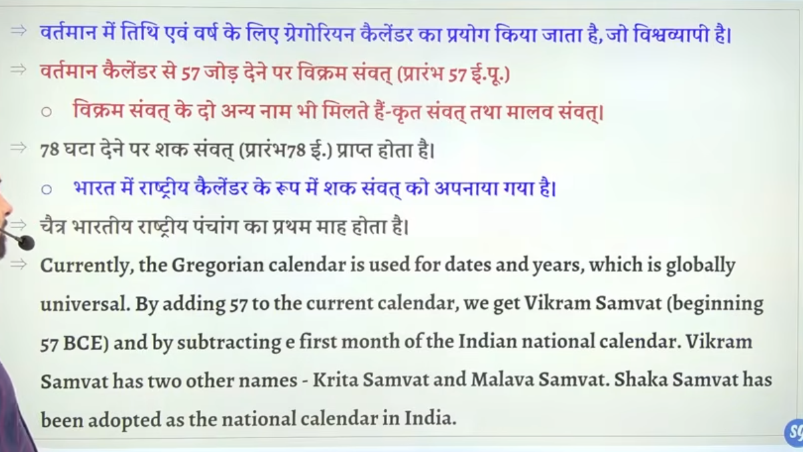

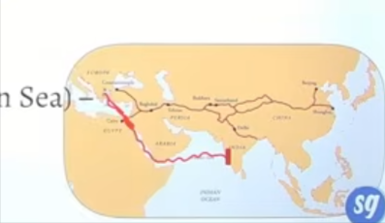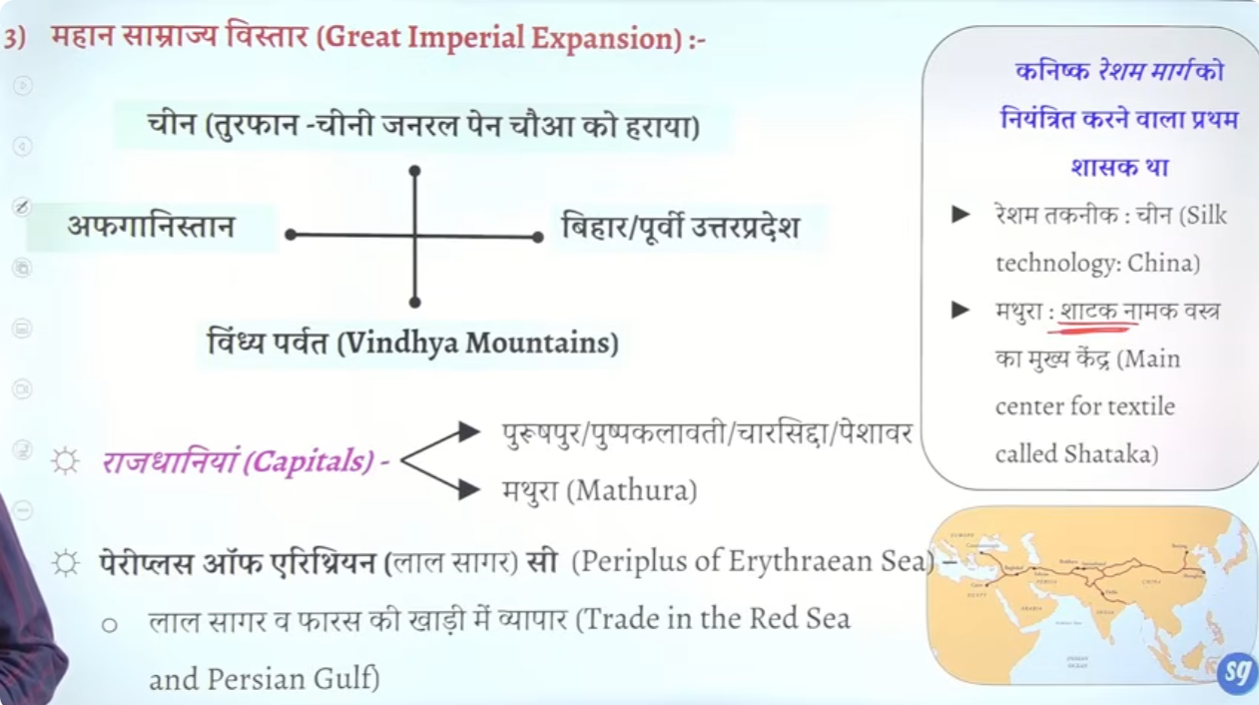

Work of Kanishka

Kanishka ke samay Kushan samrajya ka sarvadik vistar dekhne ko milta hai
Ot jb Kanishka rule kar raha tha us time per hume kushano ka maximum expansion dekhne ko milta hai inke north seema china se milte the
China ke sath iska yudh hua tha china ka general tha pan choa jske saht Kushan ke do yudh hue the
Pahle yudh me kanhishak haargyaa tha and dusre yudh me Kanishka jeet gayay tha usko harane ke baad china ke kuch hisso me Kanishka ne rajyaa bhe kyia tha

And south border Vindhya parvat se jakar lagta tha
And jo east seem hai wo birhar tk the
Western boutndary afganishtan se jakar lagte the

To hum kah sakte hia kei ek vishalykya samrajy bana lyia tha kanishak first ne

Ek book hai perpelus of erthirian sea jo shayd roman navika ya Greek naviko ke dwara likhe gae the periplus of erthidan sear means erthiran sea ke yatraey means red sea

Ertihiran sea lala sakgra ko bola gaya hai
Is pure book me batya gaya hai ke kaise ye log trade karte the south india se trade karte the kaise arbian sagar se hote hue red sea se hote hue kiawe rome Greek pauchet the

Seenaen pensuela mistral Egypt ka waha tk saman ship se latae uske gae land route ko tay karte the fir age jahaj ke medum se rome tk saman lekar jate the
Ot yahe kahaneyai preipuls of erthiran sea me bte gae hai
Vishes taur per sangar rajy o ko mention milta hai

China se Resham banana ke technique shure hue tha fir ye bharat ayay fir bhart me vish taur per Mathur jo ke ek trade centaer bana whaah shatak nam ka vastra banta tha

China ke silk ke maang pure Europe me hote the
To china se ke marg tha jo lke land se jata tha jo jameen ke trhogh jatatha aur Europe tak apuchat tha is route ko naaam dyai gaya tha silk route kuki silk ak trade sabse Jayda hota tha
Baad me isme he gt road ko bhe joda gya ht a

To is silk route per bhe kanish ne adhikar kyia tha jo route uske state se hokar Gujrat ath use ow kafi paise kamata tha isse kanishak ko ache kahse income milte the

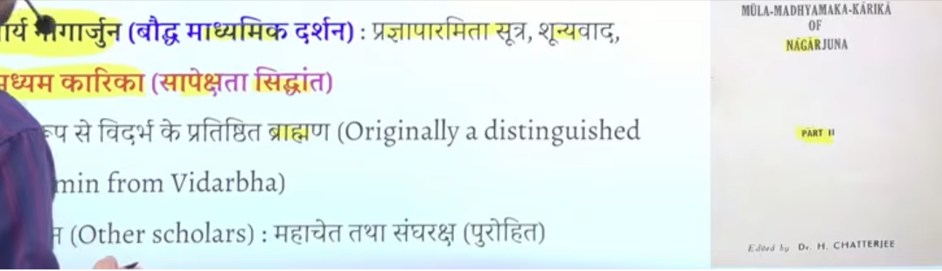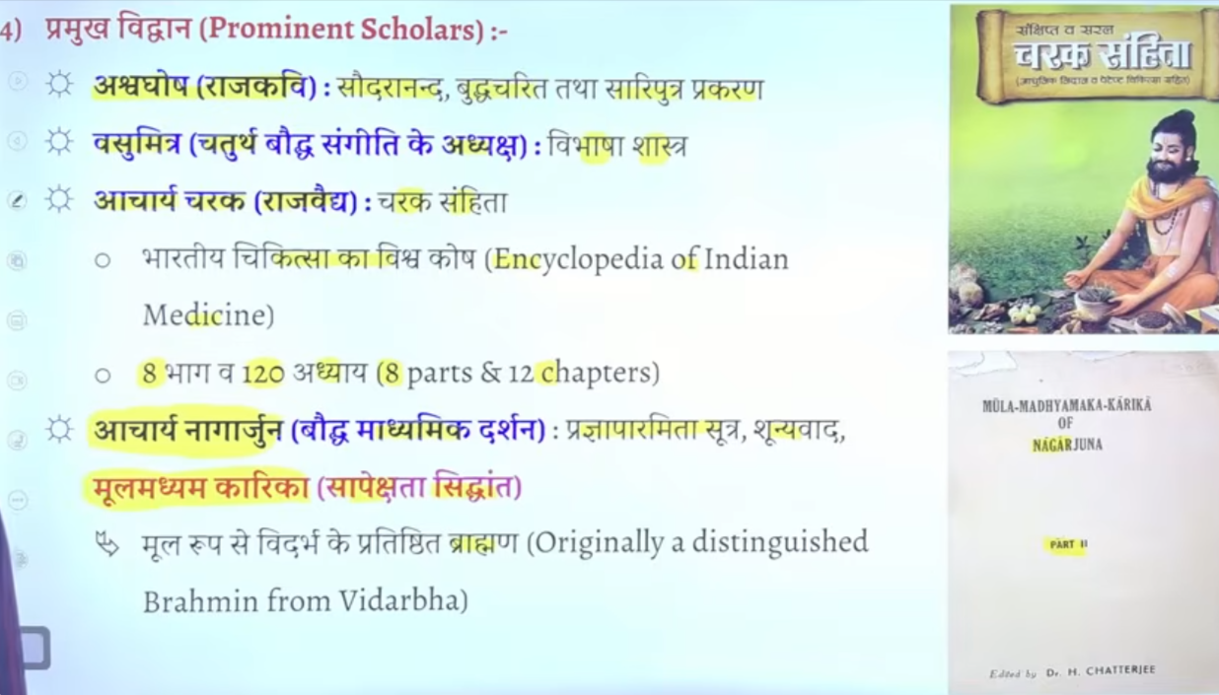

Bhartyme me mahan rajao ke darbar me mahan kavi and great scholor rahe hai ye aise rjaja the jihone scolor ko sankrakshan dyia tha
To kasishak ke time per bhe us time per india ke greatest scolor the jisme sabse bada naam hai aswvgoshk jo ashvagosh hai wo kansishk ke court poet the
Aswvagosh he foruth buddhist council ke upadhyasksh the vasumitra adhyaksh the

Foruth budhist council kansihk ke time per kundalwan me hue the

Aswavagosh en teen important book lkehe hai jo buddhsim se jude hai

Kansihk ked armbar me basumitra bhe the inke book ka naam hai vibhashashtra

Bharat ke maahna aurvedio me charka ka naam ata hai wo kasnishak ke darbar me rahtee the
Wo inke court physian raaj vadidh the inhone charak samite book likhe jise bhartyia aurveda ka vishwakosh kaaha jata hai jis enclopydian of Indian medicine kaha jata hai
There are total 8 part and 120 chapter

Nagarjun bhe inke court kanshik ke darbar se jude hai nagarjun jo shunyavad and madhimekvaad ke pravartak hai budddha dharm me
So ye important scholors rahe hai kansih ke court me

Kanishak ka sabse important inscritpon hai sarnaht inscription jo ki 81 ad ka hai
Dharmarjaik ko jo ke takshila se mila hai
Kausambi abhilekha ye prargraj se mila hai
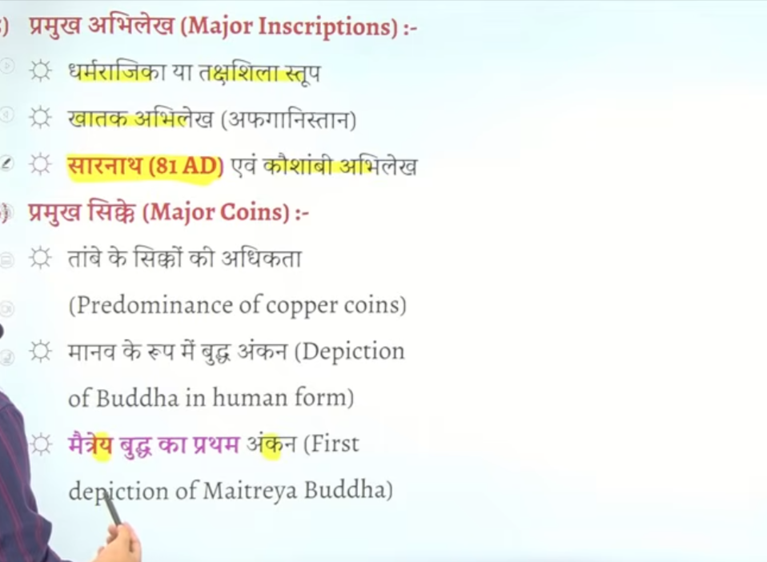

Bhale he kushano ne sabse pure gold coin issue kyia inke sahahsn kaal me copper coin tambe ke ssikke abundance me the
Kanishak first mahayan buddhism ka nauyaee tha

Kanishak se sambaned bahtu sare jankari hume 81ad Sarnath abhilekah aur kausambhi abhielkeh se mitle thai ye important hai

Kanishkpur shahar ke isthapan kashimir ken ikat kanish ne ke the isne ye naya Sahar basya tha

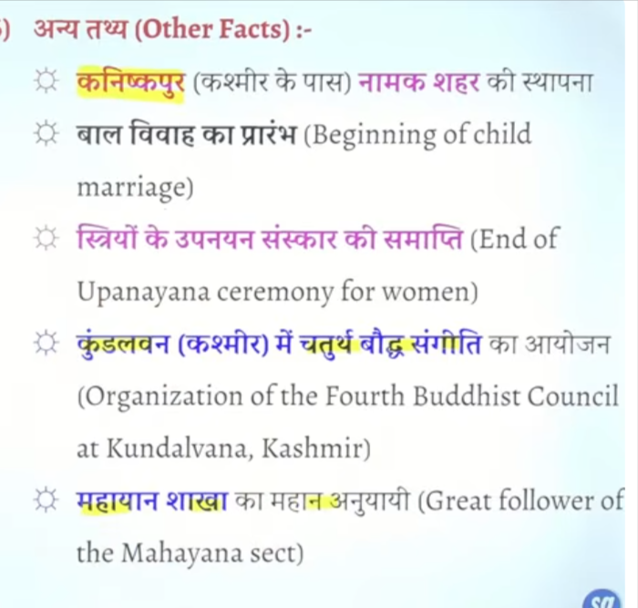

Mauryotar kaal me kusano ka samay ias tha jb female education ko pure tahra se band kyia gaya aurpchariek roop se means officala roop se
Aur baal vivah jaise kururtyion ke shruat hog ae the
Jo show karta hai ki women ke condition kafie detervate ho gae the

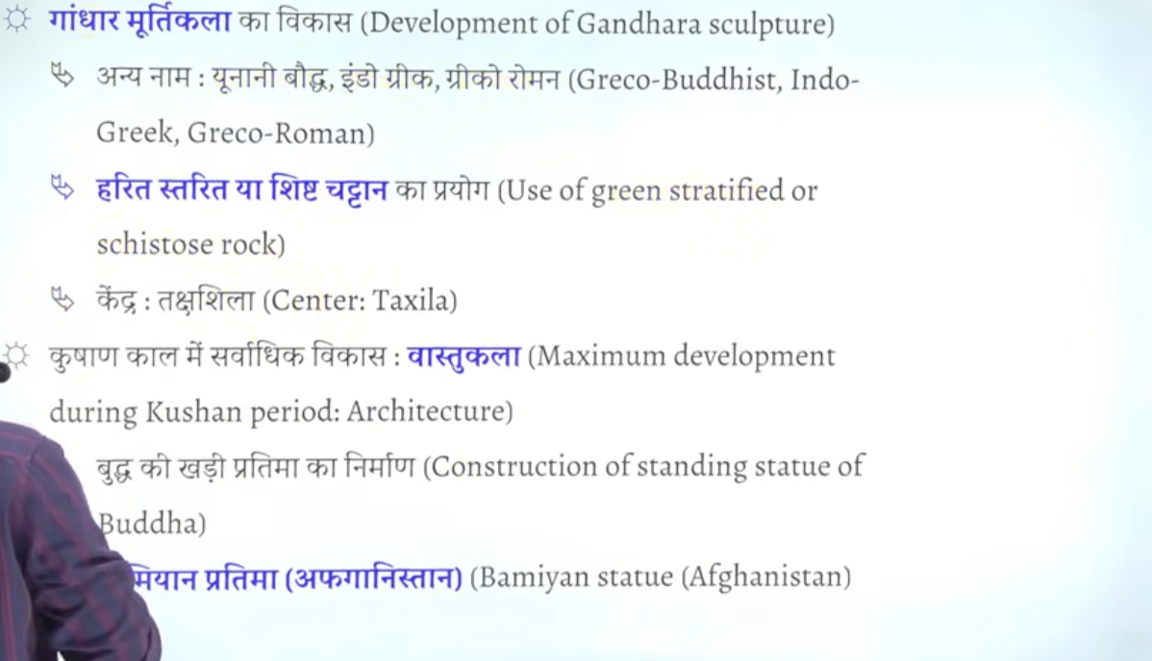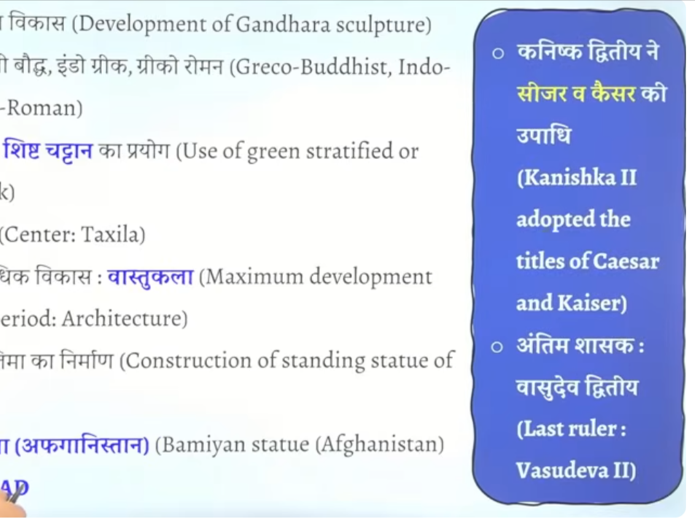

Kaisnshik ke tiem per he Gandhar murti kala ka vikas hua tha jisme green schist stoen ka use hota hai

Sabse pahe manav ke roop me Bhagwan ke jo murte bane gae wo gautm buddha ke he bane gae the aur manav ke tarah eh bahgwan ko darshay gya
Buddha ke mrutyiao much roop se do shaileyon me baene gae the ek mathrua shaile jo bharat ke deshi shaile the
Aur dusre Gandhar shaile jo mathrua and Greek ka misrad the

Difference check
Gandhar kala me bhavatya per jyad dhyan dyia gaya hai Mathura kala me sprituality per Jayda dhayn dyia gya hi mathrua kala me lala pahtahr ka use kya gya and Gandhar me green schist soten ka use hua hai

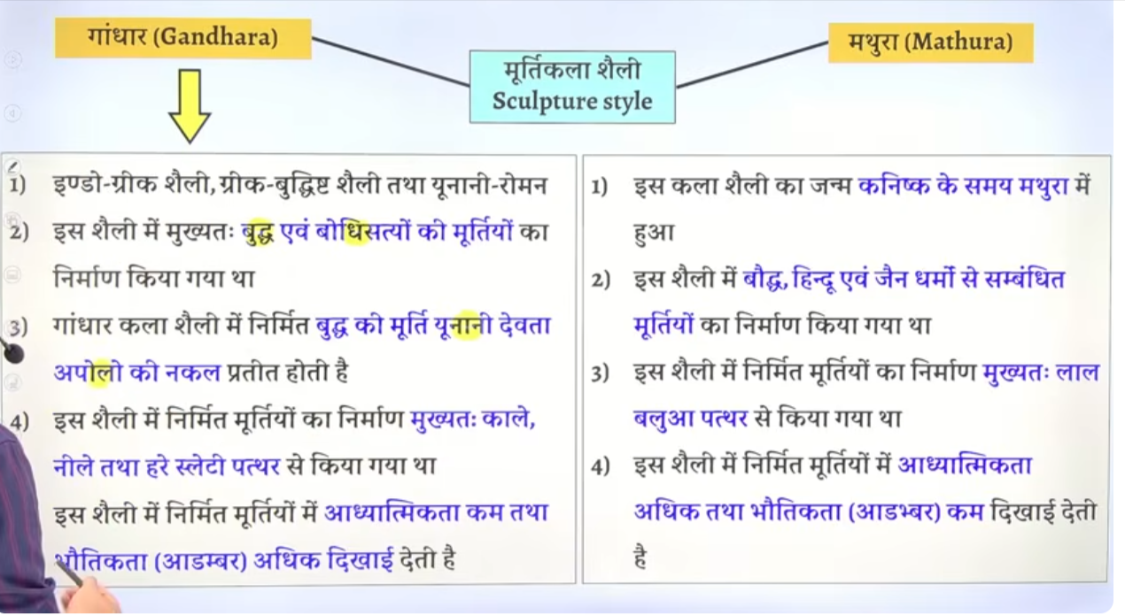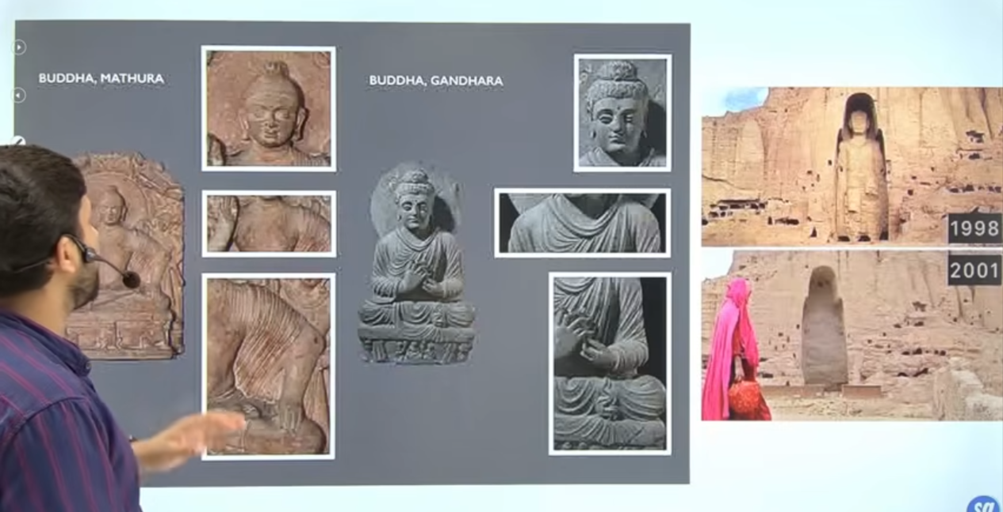

Kanishka ke tiem per he hume afganisthan mebamiyan me buddha ke khade hue prateema dekhne ko mitle hai talibaan ne is murthi ko khmt kar dyai tha

Kanishka ke death 102ad me hote hai
Iske baad weak succor ate hai jism eke Kanishka second naam ka rjaj aht ahi
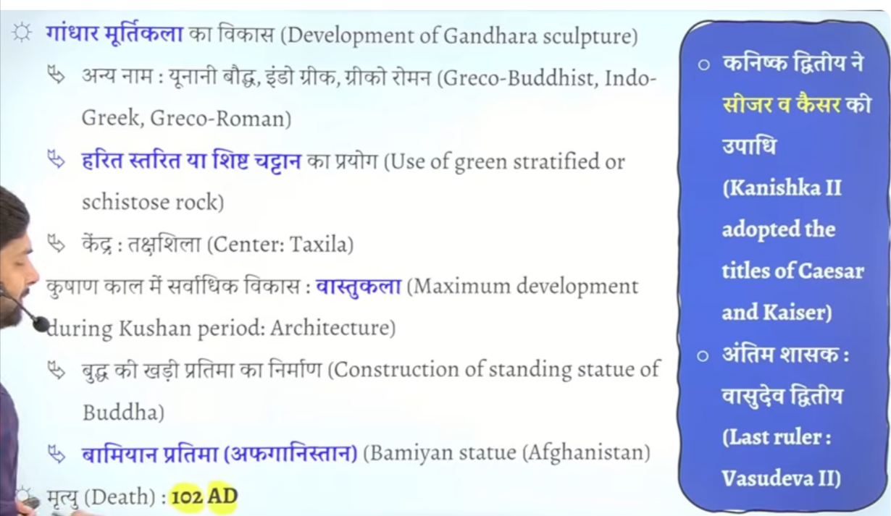

Kanishk et time per he charak jaise mahan scholor hue and nagarjun jaise scholor hue
Nagarjun jo budha dharm se relate hai unhone buddha dharm me madhyamik darshan ke Shurat ke aur mul madhyam parita kakre book likhe

Kanishak first ke tiem epr he Gandhar and Mathura kala ka sarvadhik vikas hua

Gandhar kala me green blue and black schist slate e pathar ka use hau
And bmathura me red stoen

Sarnaht inscprotn 81 ad ke Janki 81ad ke janikari deta hai

Post Mauryan time period Fact

Bahut bade matra me vedhese post Mauryan tiem ke baad bharat aeyeye aur unko bhartyiakarn ho gyaa

Post mauryna tiem per ke varn vayavastha m ek new sankalpana ko shru kyia gaya jise apad dharma kahh gyaa tha apad dharma ka concept pahle nahit tha jb vedeshi aa gyae tb varna vyavasta ko lekar unke scok kaft alag the
Jo ismrit dharma hai usme apadh dharm ke baat keg ae hai mean jb crisis aye to vibhanean varno ke log anya varno ke karya kar sakte ahi to varna vyavsta ka use jb kam hua to har koi koi bhe kaam kar rahah ahi tb adaadd dhmar ke sankalpan nikle

Ambast kya hai check

Jb vedshi sahshak aa ge tb varna vyavst pure tarah palan nahi ho paa raha tha kuki wo each varna se koi bhe kaam karwate the tb hindu dharm k logo ne apadh dhamr ke sankalpana niklae aur justify keya ki vepatee hai to koi baat nahi ek vrna dusre varna ka kaam kar sakta hai

Q ytra nariyost pujuate tantr devata naamka pankti kaha se le gae to ans is manusmirit se le gae hai

Halake isee manusmirit me womena ko kuch aise bate bhe kahe gae jo sewakrya nahi hia

Q wha tis punarbhu , punarbhav kya hia

Do tareke ke vivah hone lage the ek anulom vivah aur dusra ek prateelom vivah
Anulom vivah means uccha varna ka puruas nimn varn ke mahila se shadi kar le to wo anulom vivah maana jata tha aur samaj usko swekarya bhe karta tha
Lekin agar uccha varna ke mahila ek nimn varna ke purus se shadi kar le to samaj use accept nahi karta tha usko prateelom vivah ke naam se jana jata tha
Kuki patriarchail society ahia pursush satatmak samajh hai to wo usko accept nahi karta tha

Ambasth jb brahman purus and vaishy mata ke santan ko ambasth bottle the
Kuki ye anulome vivha hai purush ka varna bada nd mahila ka varna chota hai to isse samaj ke bhe acceptance milte the aur ye dekha gayay hai samajh me jinte bhe ambasth naam ke santan hue unhone generally medical ke field me he age gae hai

Abmasht ko samajik swkrte the kuki ye anulome vivha se utapan hue hote the

Chandalo ko samajh me koi acceptance nahi the inke isaht bahtu bura bratva kyai jata tha extreme untocuahability perform ke jate the inke sah asprasyta aka behavious apnya jata tha

Inke main occupation cremation shavdah karna tha

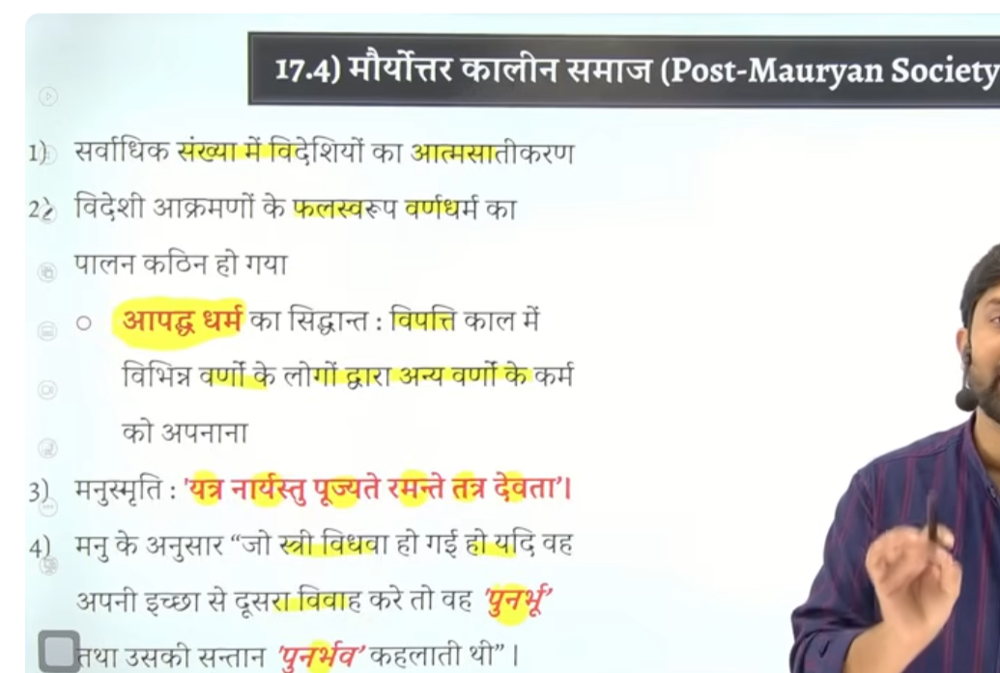

Post Mauryan time per sati pratha nahi the but baal vivah ke Shurat hog ae the
Aur Kushan ke time per to ye ke

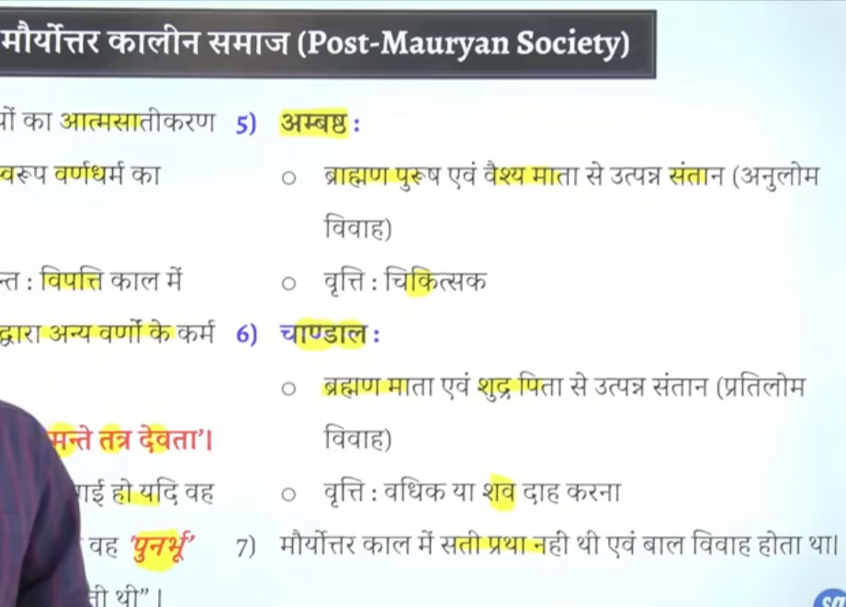

Kusahn ke time per chil marriage ke institualnal framework ka rop le chuka tha

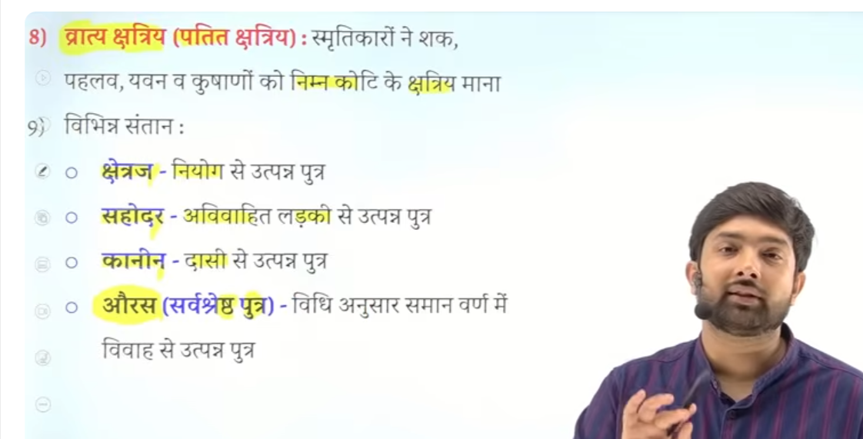

Pot Mauryan time per basically jo king hot tha wo chatryai he hota tha but fb foreint invader in akraman karke king bane to unke lei smirtiyon me vratya chatirya word nimn koit ke chatrya use kya gaya tha isko patet chatryia bhe kahah gaya tha
Vedheysion ne bhaut bade bhu bhag per kabja kar lyei tha ab inhe kya kahe inhe bhe to kuch kahna padega vrat chatrya kaha gaya

Auras ko sbse ache santan maja jata tha kuiki ye ucha koti ke vivah se utpan santan the isley isko sbaee ache prakar ke santan mana jata tha jo vede vidahn ske anusar kyia gae vivah se utpann ho

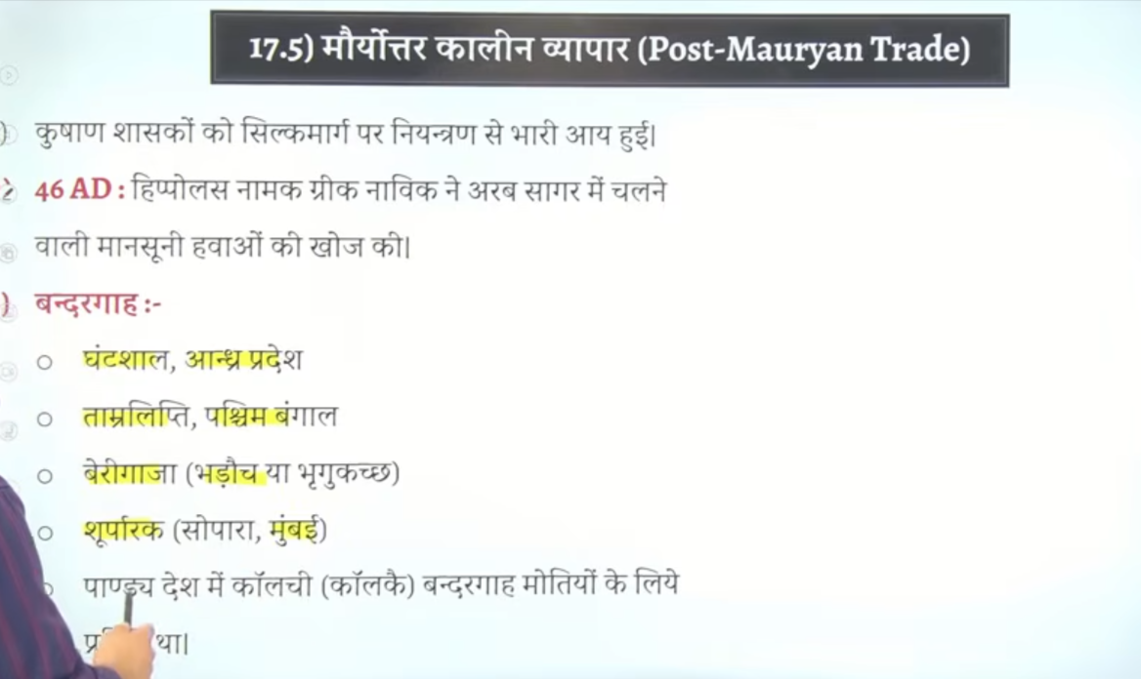
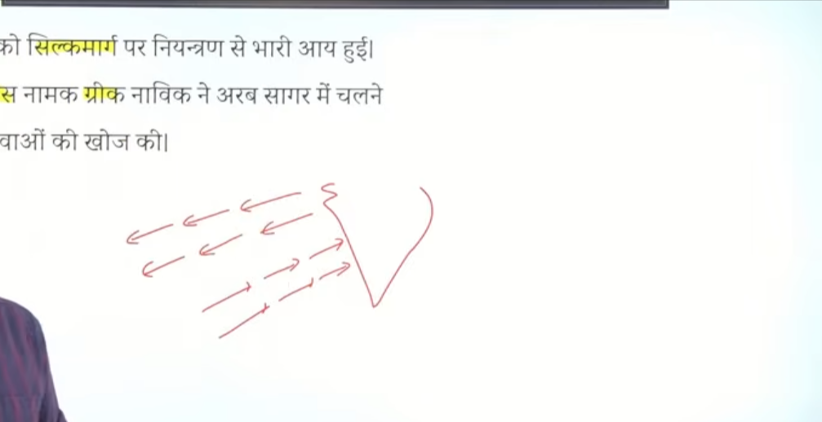

Hippols namaka kek grek sailer tha usne mansosne hawao ke bare me pata lagay tha halaki ye mansoon sabhd baad me ayay tha to humko bol skte hai kiusne hawao ke pattern ka ptat laga lyie tha
Ki ye jo arab sagar aur hind mahasagr wala elkaa hai isme hawao ka ek pattern hai kuch samay tk hawaye south west se north east me chate hai kuch samay iske opposte chalte ahi
Jisse jahasjo ko chalane me asane hone lage the
Jo navik the wo mansoone hawao ka palan karne lage the jisse naav chalana asan ho gaya
Unfortunate baat ye rah eke jb vasco di gama bharat aya tha to wo bharat jaldi aa gaya tha kuki wo may ke timer per bharat ayay tha us time per mansoone hawaey bharat ke taraf chalr rahe the but jo bharat se vaspis gayay to uske jane me time laga kue tb hwaw bharat ke taraf me hcal rahe the
To usko jane me kafi time laga tha
Aa bahut jaldi gyaya but jane me kafi time laga tha mansoon ke wajah se



Acutalry me jo pura ka pura pandeya desh hai wo pearl ke lyei moteiyon ke lyie famous tha
Woahah per kaulchi naam ka bandarhgah tha wo peralr ke lyie bahut famous tha
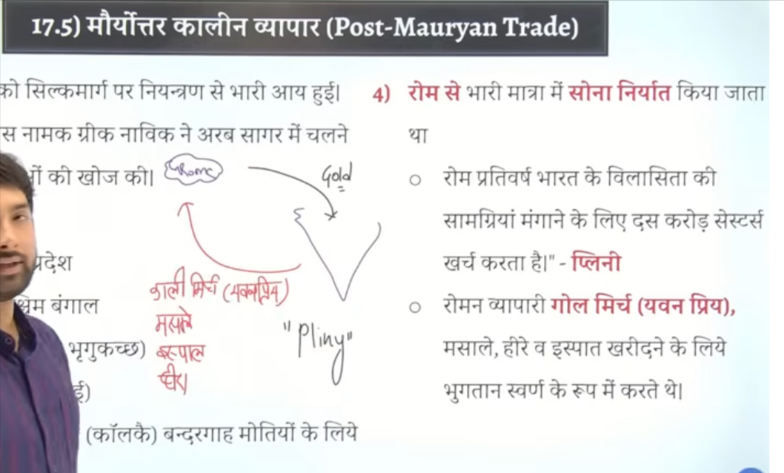

Is tiem per bharat ka bhaut badya trade rom eke sath hota tha kuki hum rome ko kalimirchi masala, loah bejte the heera bhejte the badle me rome se hum gold lete the
Pliny naam ka ek scholor tha jisne sabse pahel is bare me concern jatya tha k eke bharat ko hum bahtu bade matra me gold bhej rahe hai aur bharat se hum jo saman le rahe uske badle me

Bharat ka trade rom eke sath itna jayeda tha ke pandecherry ke paas ek arekmedu naam ke jaghah hai wahah roman bastyia mile hai augustus naam ka raja uwhaha per useke coins mile hai to arekmedu bhaut important cjagha the jaah roman raha karte the aur rom eke trade ko bharat se sambahltethe

Roman yaha rahah karte the aur bharat ke vyapar ko sambahlte the 4

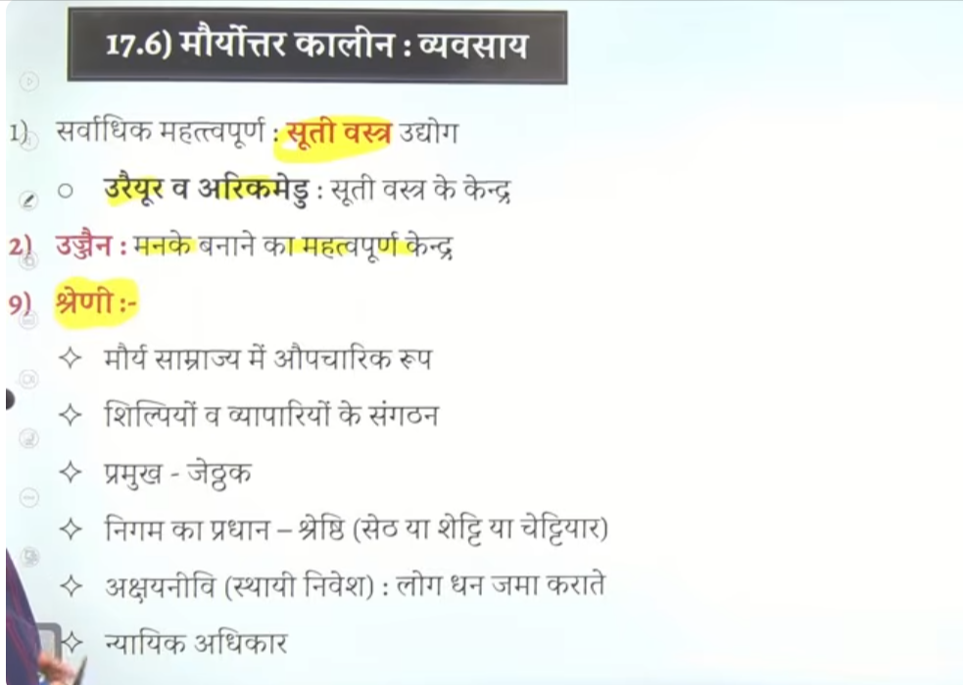

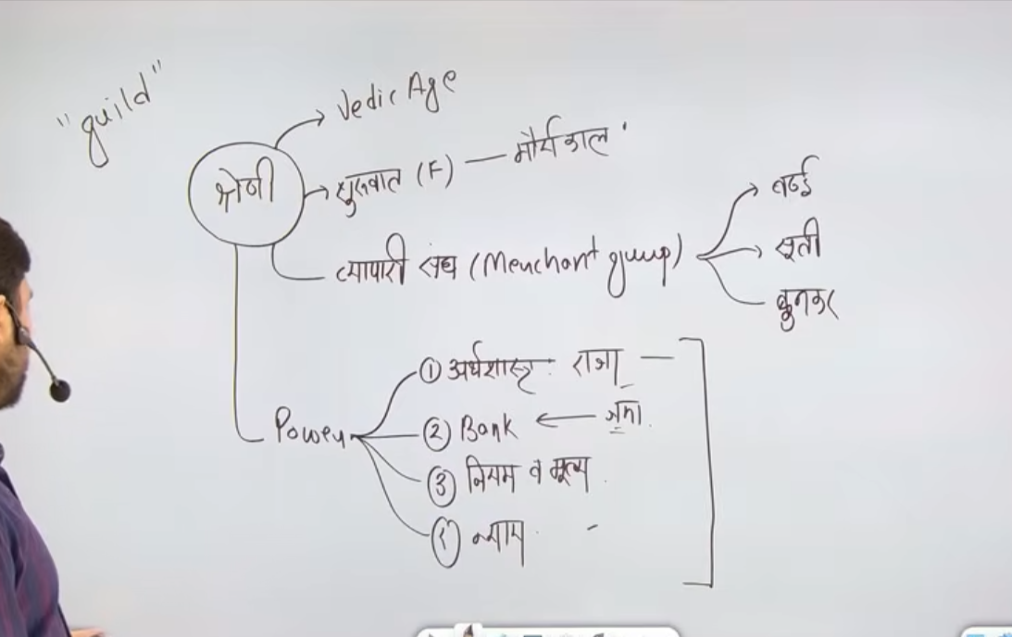

Jo shreni system hai ikse old traced hume vedic age me milte hai but ikse jo videhvat shuratat hue hao format roop se starting hue ho Mauryan period se start hue hai

Shering = merchant groups hote the unko he sherini kahah gya
Jisse badahe ka alag group hai , weaver ka alag group hai , contton textile ka alag group hai
Isse vyayatako hum sherin kahte the English me guild word use kyai jata tha

In sherini ke paas bahut sare shaktyian power hote the

Arthsaht me likha hua hai ke rajaj ko bhe shernike baat manee chaye king must obey sherni
Shreini bank ke tarah bhe work karte the log apna paisa isme jama katre the

Sherini apne niyam and Mulya khud taya karte the like kapde ke sherni hai to wo khud taya karte the ki vastra kinte me bechan ahia aur baki ke neyam bhe

Isse tahrah nayaya ka akaam bhe khud he karte the kuch bhe shernim me gadpag hote the
To uska nayay bhe khud katte te

Vyapapreyon ke sangh ko shereini kahah gayay hai iske shruat Mauryan kaal se hue aur ye agee chalte he jayega age eke period me
Sherini nayayah ka kaam bhe karte the bank ka kaam bhe karte the jaise paise jama kanra apne nyiam bante the Mulya taya kartee the ise vyavasth ko sherni kahah gya hai

Sherini ke pramkuh ko jhetak bolte the

Aur sherni ka Pradhan ko shresthi, seti ya chettyar bote the

Aj bhe company ke lyie social corportate responsibility de gae hai ek parka rse dcoroprate social responsibility ka kaam bhe karte the

